API PART II

Materials Needed:
- A computer with Flutter installed.
- A code editor (like VS Code or Android Studio).
- The provider package installed in your Flutter project.

Instructions:
Use the previous code to before starting.
Replicate the code snippet.
Follow and implement the enhancement instructions.

Steps:
In your surname_advmobprogAY2627 (root) under it surname_advmobprog make the following
Clean the pubspec.yaml (sample only)
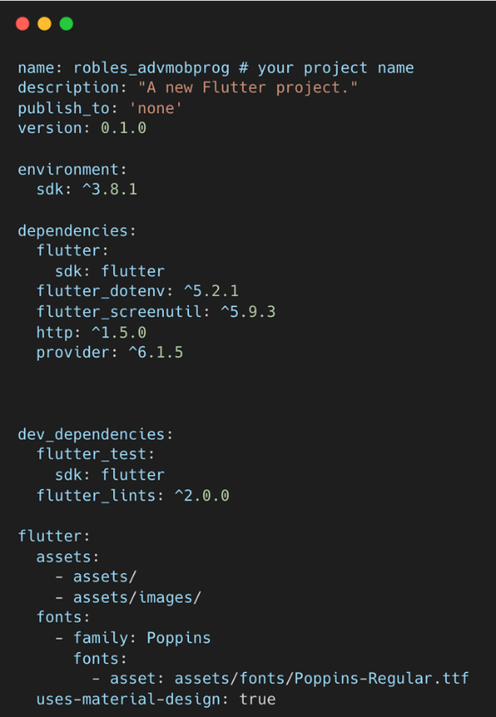

Create these folders and files under the project folder with this design pattern.
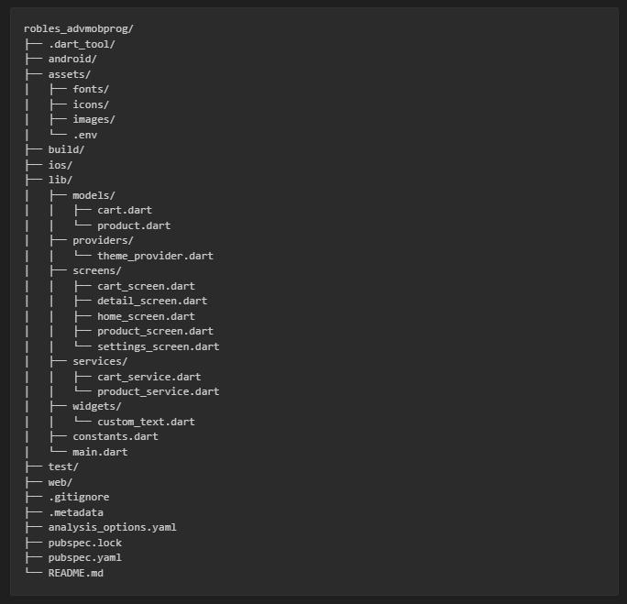

Source Code
model/cart.dart
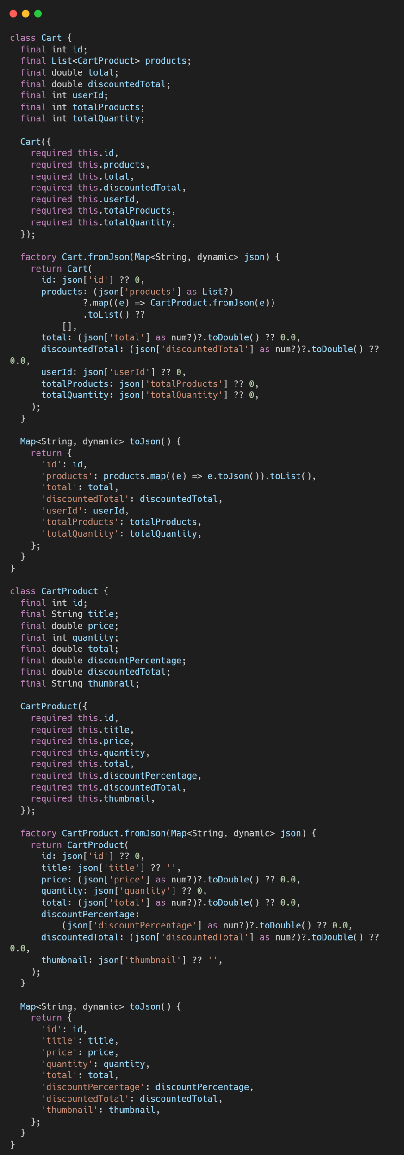
service/cart_service.dart
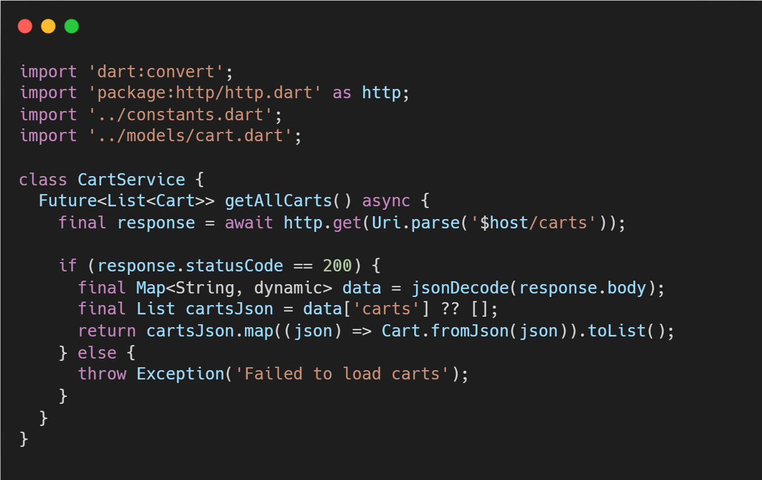

Enhancements:
Comment in the source code each enhancement you’ve been implemented.

Enhancement 1: Make a cart_screen in order to render the new API endpoint. The items on the cart_screen must be clickable going to the detail_screen for the utilization of the screen widget.
Enhancement 2: Make the chat bottom navigation as FloatingActionButton. When in the cart_screen the FloatingActionButton must be hidden.
Enhancement 3: Read the Cart documentation https://dummyjson.com/docs/carts and check how to integrate cart by user id. To render only one user cart. Also try to use add to cart by passing the values of the product => cart https://dummyjson.com/carts/add

Sample Output:
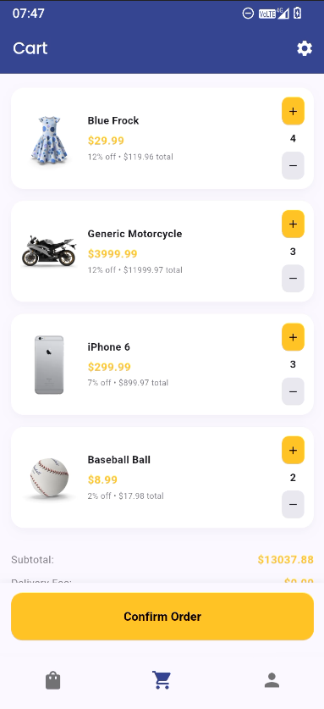
Laboratory Discussion: Discuss how the cart model, services and screen interact with each other to render the API endpoint going to the same detail_screen.dart. Discuss the updated design pattern in this activity. Also discuss how to use getbyId at Cart endpoint.

Git Instruction:
Update first the README.md file adding the discussion part for example:
Lab Activity 3: discussion

after the hands-on and updating the README.md (must be on root folder surname-advmobprogAY2627)

1. git checkout -b lab_act3
2. git add .
3. git commit -m “lab_act3”
4. git push origin lab_act3

Activity Rubrics

Criteria | Excellent (4 pts) | Good (3 pts) | Fair (2 pts) | Poor (1 pt) | Points
Code Implementation | Code runs flawlessly, includes all required features (placeholders, avatars, widgets for like/comment). | Code mostly correct, minor errors, or missing one minor feature. | Noticeable errors or missing two or more features. | Code does not run or is significantly incomplete.
Design Consistency | UI closely resembles intended layout, proper spacing, alignment, and styling. | Layout mostly accurate, minor spacing or alignment issues. | Layout deviates significantly from the intended design or appears incomplete. | Layout is unrecognizable or does not follow the instructions.
Use of Widgets and Enhancements | Properly implements widgets for placeholders, avatars, and like/comment buttons. | Most widgets are correctly implemented, with minor issues or missing one enhancement. | Widgets are inconsistently used or missing two or more enhancements. | Widgets are not used, or enhancements are not implemented.
Code Organization and Readability | Code is well-structured, follows best practices, and adheres to the specified file organization. | Code is mostly organized and readable, minor deviations from the required structure. | Code is poorly organized or does not follow the specified structure. | Code is disorganized and difficult to understand.
Back-End Integration | Back-end integration works flawlessly with efficient API calls, secure data handling, and real-time updates; no errors or downtime. | Back-end integration is mostly correct with only minor API, data, or response handling issues. | Back-end integration has noticeable flaws or inefficiencies; multiple API calls fail or data handling is inconsistent. | Back-end integration has major issues; frequent failures, poor response handling, or insecure practices.
 | Other Comments/ Observations: |  |  | Total Score
 |  |  |  | Rating: (Total Score/20) * 100

